
Break root Passwd-RHEL in single usermode
Prepared by Vonteddu Sreelaksmhi 
Date: 30-11-2025
Confidentiality: Internal Use Only for Bayer
Step:1
check in datastore space and take snapshot if until 1 or 2 Tb
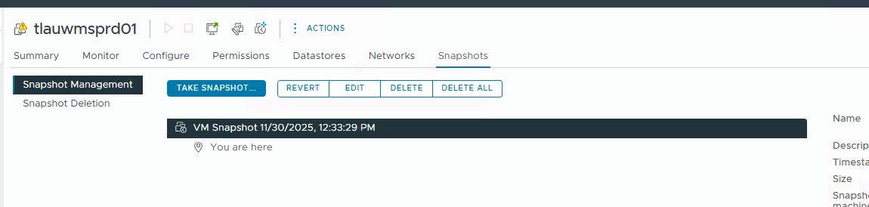
Step:2
Go to Actions edit setting VM option boot options set 10000 in boot delay clik OK
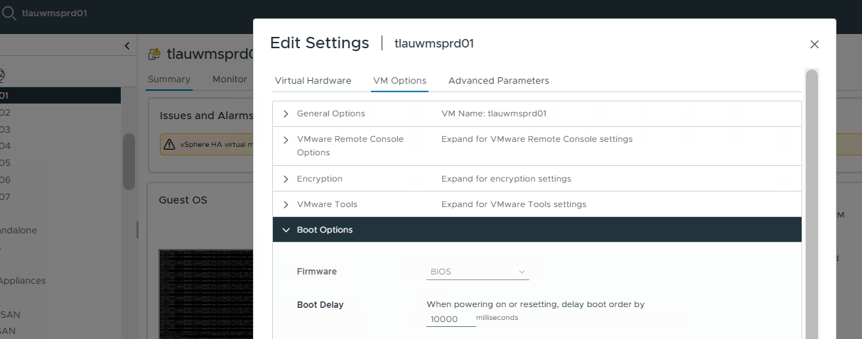

Step:3
Reboot the server from console ( Reset)
In console give ESC --ESC add linux line end “init=bin/bash” ctrl+X to same and went into singl user mode

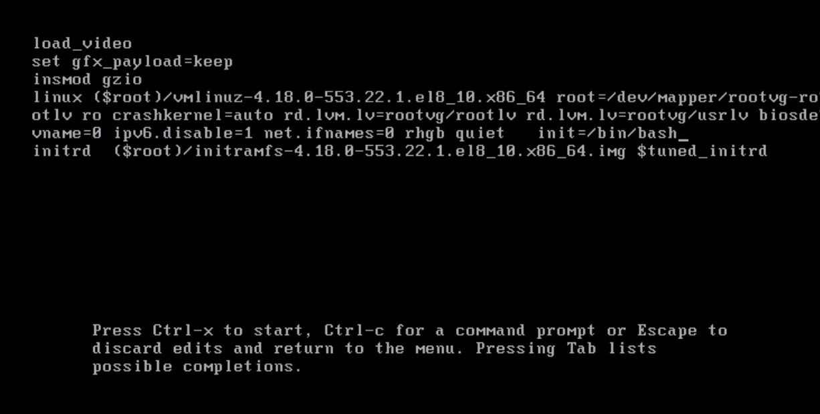
Step: 4
$ mount o remotn,rw /
try to reset passwd if give below error need to modify passwd-auth, system auth file.
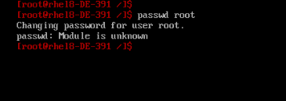
modify password-auth, system-auth file under /etc/pam.d
$ cd /etc/pam.d
$ ls -ltr
$ cat password-auth
$ cat system-auth
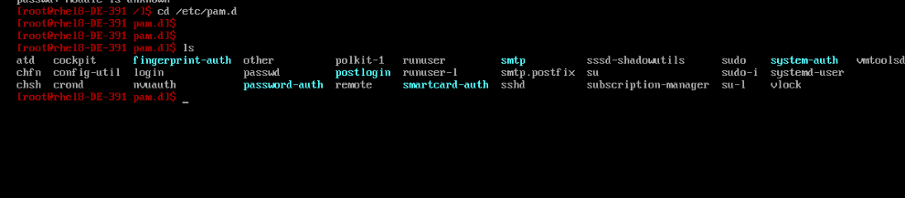
#out vas3 lines then try to reset passwd
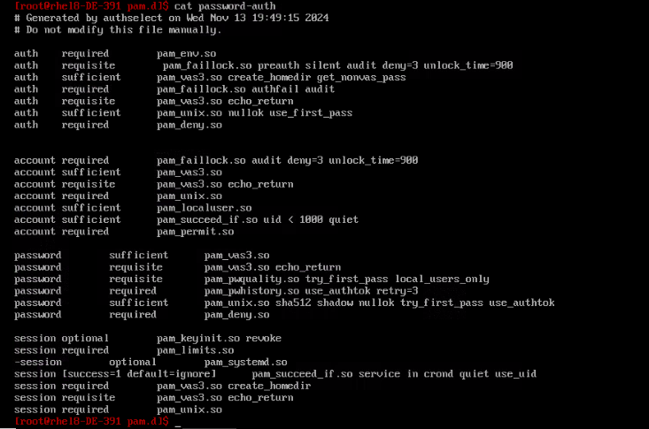
#out vas3 lines then try to reset passwd
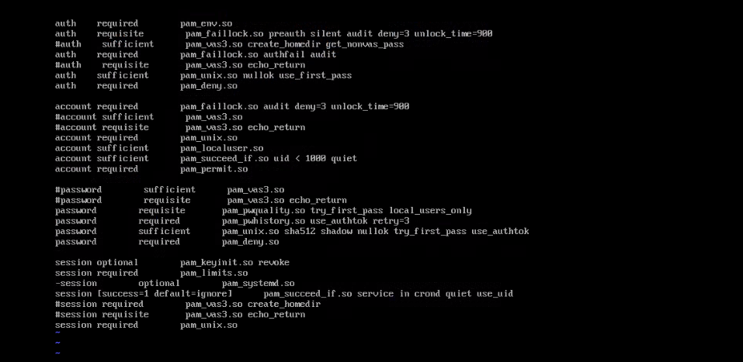
once reset passwd
$ passwd root
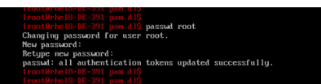
Once reset root passwd need to remove # in files
$ cat password-auth
$ cat system-auth
then reboot the server by giving “exit”
$ exit
